The Memory Club
Calendar of Events : October 2014

Monday | Tuesday | Wednesday | Thursday | Friday
 |  | 1 Seniors’ soup Group.  Guide Hall, Soroba Road. 1-2.30 | 2 65 Zumba Gold  Glencruitten Church  1.30-2.30  Silver Notes  Lynn Court, Oban  3 -4.00pm | 3 Frail Walking Group  Salvation Army hall  10-12pm  Stitch n Time  Salvation Army Hall, Oban  2 -4.00pm
6 Fitness & Laughter  Glencruitten Church Centre  2-3pm  The Shed  Senior’s Session Stevenson Street  12 - 4.00pm  Careadean Muile  2pm -3.30pm  Bowman Court | 7 Coffee Morning  North Argyll Carers Centre 10.30-12.30  Musical Memories  Glencruitten Church Hall  1.30-3.30  Fitsteps 65+  Cathedral Hall  12-1.00pm | 8 Seniors’ soup Group.  Guide Hall, Soroba Road. 1-2.30  Photo Activity Group  Oban DRC  12pm-4pm | 9 65 Zumba Gold  Glencruitten Church  1.30-2.30  Mull Musical Minds  An Roth, Craignure  1.30-3.00  Silver Notes  Lynn Court, Oban  3 -4.00pm | 10 Frail Walking Group  Salvation Army hall  10-12pm  Stitch n Time  Salvation Army Hall, Oban  2 -4.00pm
13 Fitness & Laughter  Glencruitten Church Centre  2-3pm  Careadean Muile  2pm -3.30pm  Bowman Court  The Shed  Senior’s Session Stevenson Street  12 - 4.00pm | 14 Coffee Morning  North Argyll Carers Centre  10.30-12.30pm  Gaelic speakers Ceilidh  Lynn Court  2pm-3.30pm  Musical Memories  Glencruitten Church Hall  1.30-3.30  Fitsteps 65+  Cathedral Hall  12-1.00pm | 15 Seniors’ soup Group.  Guide Hall, Soroba Road. 1-2.30 | 16 Oban Health Walks  Congregational Hall, Tweedale St. 10am -12pm  65 Zumba Gold  Glencruitten Church  1.30-2.30  Silver Notes  Lynn Court, Oban  3 -4.00pm | 17 Frail Walking Group  Salvation Army hall  10-12pm  Stitch n Time  Salvation Army Hall, Oban  2 -4.00pm  Shared Words Story Café  Columba Hotel  10.30am -12.15 pm
20 Fitness & Laughter  Glencruitten Church Centre  2-3pm  Careadean Muile  2pm -3.30pm  Bunessan  The Shed  Senior’s Session Stevenson Street  12 - 4.00pm | 21 Coffee Morning  North Argyll Carers Centre  10.30-12.30pm  Musical Memories  Glencruitten Church Hall  1.30-3.30  Fitsteps 65+  Cathedral Hall  12-1.00pm | 22 Seniors’ soup Group.  Guide Hall, Soroba Road. 1-2.30  Photo Activity Group  Oban DRC  12pm-4pm | 23 65 Zumba Gold  Glencruitten Church  1.30-2.30  Mull Musical Minds  An Roth, Craignure  1.30-3.00  Silver Notes  Lynn Court, Oban  3 -4.00pm | 24 Frail Walking Group  Salvation Army hall  10-12pm  Stitch n Time  Salvation Army Hall, Oban  2 -4.00pm
27 Fitness & Laughter  Glencruitten Church Centre  2-3pm  The Shed  Senior’s Session  Stevenson Street  12-4pm  Careadean Muile  2pm -3.30pm  Tobermory | 28 Musical Memories  Glencruitten Church Hall  1.30-3.30  “Helping Each Other”  Oban DRC& Carers Centre  10-30-12-30pm  Gaelic speakers Ceilidh  Lynn Court  2pm-3.30pm  Fitsteps 65+  Cathedral Hall  12-1.00pm  Senior Forum  Lynn Court, Oban  10.30am | 29 Seniors’ soup Group.  Guide Hall, Soroba Road. 1-2.30 | 30 Oban Health Walks  Congregational Hall, Tweedale St. 10am -12pm  65 Zumba Gold  Glencruitten Church  1.30-2.30  Silver Notes  Lynn Court, Oban  3 -4.00pm | 31 Frail Walking Group  Salvation Army hall  10-12pm  Stitch n Time  Salvation Army Hall, Oban  2 -4.00pm  Monthly Memory Club Lunch  Columba Hotel  12.30-2pm

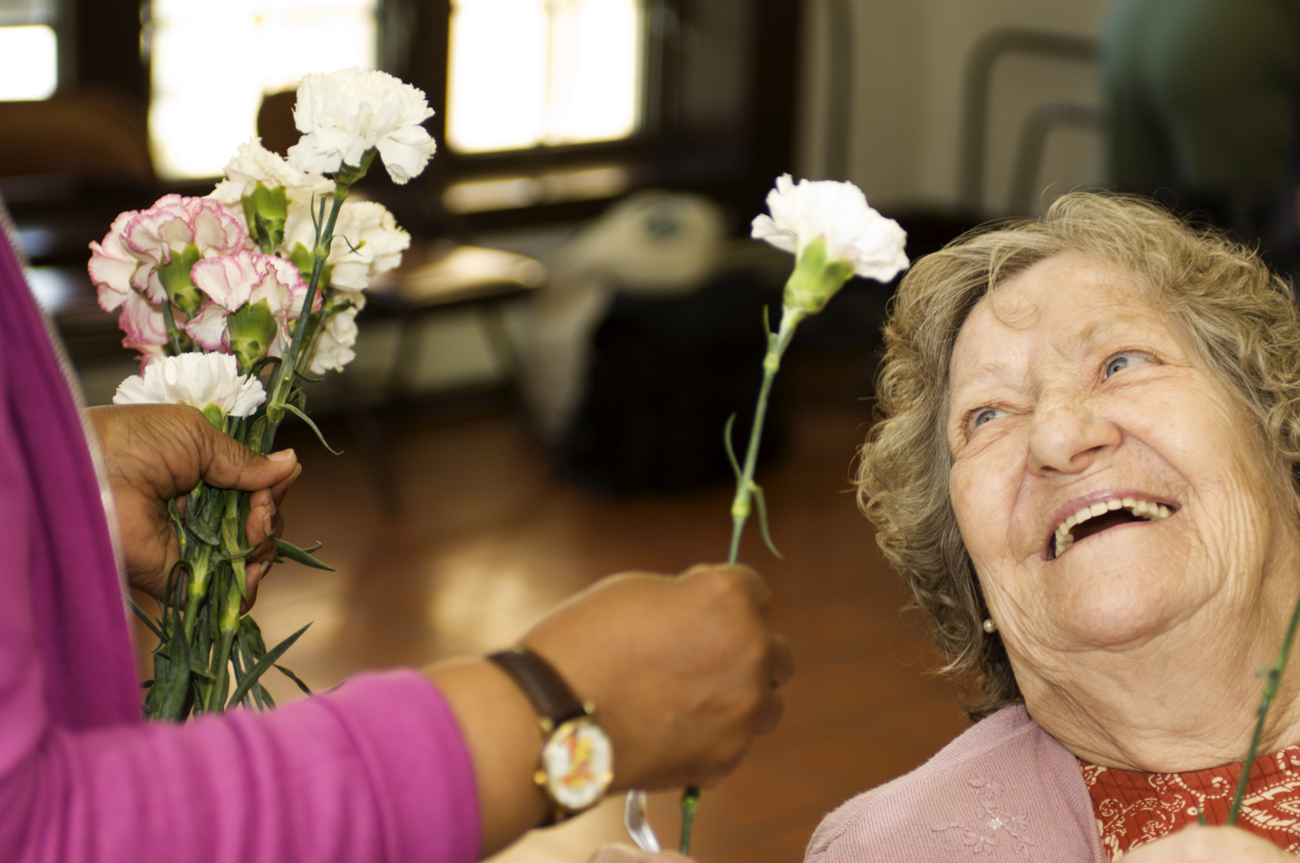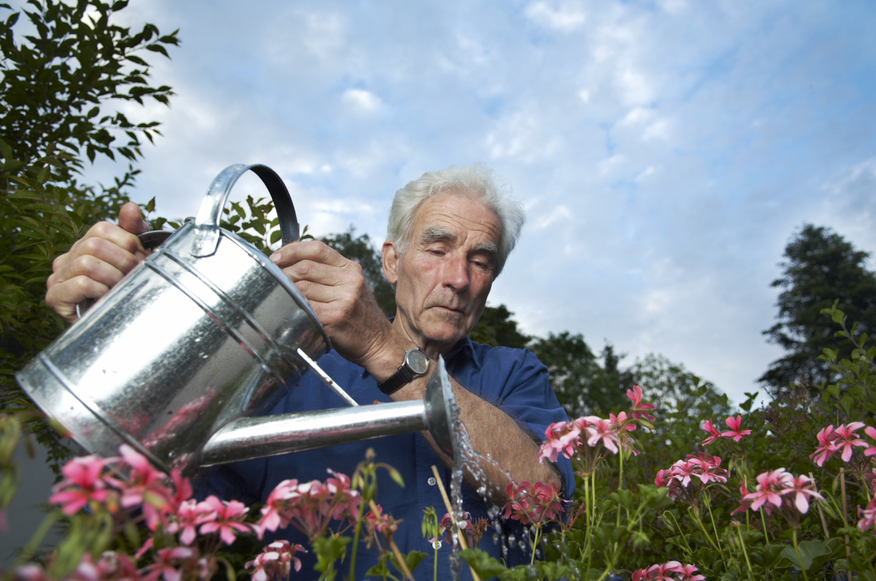
Welcome to the
Memory Club Calendar: October 2014

Well September has flown by, and what a beautiful sunny month it has been. We hope you have had the chance to get out and about and make the most of it.
October’s Calendar is looking full and flavoursome and ready to be picked just like the brambles in the hedgerows. So here’s wishing for the fine weather to keep going, so we can all get out the door, meet up and enjoy the activities and events that are waiting for us.

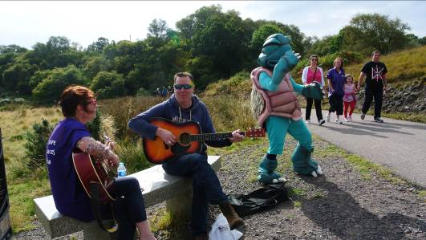
September was Memory Walk month for Alzheimer Scotland, with walks taking place all over Scotland. Here in Oban we had a fantastic turn out for our own Memory Walk on Sunday 14th. The weather was kind, and almost 80 walkers of all ages met up at Ganavan to walk the cycle path to Dunbeg and back.

We were joined by some great musicians and even a giant Sea Turtle called Marcello, which all helped to make for a really memorable and enjoyable afternoon. Our thanks to all the walkers, the volunteers from the local branch of Alzheimer Scotland, Ali, Jim and Helen for the fantastic musical accompaniments, Marcello for turning Turtle, and Oban’s Lidl’s and Tesco’s stores for the kind donations of refreshments.

Ali who was playing and singing for us on the walk is also the singing leader at Musical Memories singing group (Tuesday afternoons from 1.30-3pm at Glencruitten Church Centre), and together with Fumiko and the fantastic group of volunteers they create a warm and welcome place to come along and have a tea or coffee and a blether followed by a great sing song. If you have never been before, why not give it a try! For more information contact Andy Crabb on 01631 570614
.
This month’s Story Café, an eclectic and enticing mix of stories, poems and songs will be from 10.30am to 12pm on Friday 17th October at The Columba Hotel. Please contact Andy or Davy at Oban DRC (01631 570614) or Jim at North Argyll Carers Centre (01631 564422) If you would like to come along.

September’s Monthly Memory Club Lunch will be on Friday 31st October at 12.30 - 2pm. Please do let us know if you would like to come along and join in, it’s a great way to meet new people and enjoy a delicious lunch in a relaxed environment.

With all our best wishes,
Andy
Andy Crabb
Dementia Advisor
Oban Dementia Resource Centre
12 High Street Oban. 01631 570614

