Musical Memories  A sing along and a get together at the resource centre. Song requests at the ready! | West Dunbartonshire  Resource Centre  6-8 Miller St  Clydebank  G81 1UQ | 1st Tuesday of each month | 6pm-8pm
Dementia Advisor Drop-in café  Drop in at the resource centre and meet other people for a chat and a catch up. Tea, coffee and biscuits available!. | West Dunbartonshire Resource Centre  Resource Centre | Every Wednesday | 10:00-12:00
Drop-in café  Our Balloch drop in Café takes place at the beautiful National Park HQ building. Come along and have a blether over a cup of tea! | Loch Lomond & Trossachs National Park HQ Carrochan Rd  Balloch G83 8EG | 1st Thursday of each month | 11:00 – 12.30
Carer Support groups  Peer support for people caring for someone who is living with dementia. | Langcraigs Day Centre,  Gooseholm Road,  Dumbarton | 2nd Thursday of each month | 7pm-9pm
Allotment Group  Our dementia friendly allotment is a great outdoor space to meet others and do a spot of gardening, or simply relaxing outside. | Dumbarton East  Eastfield Crescent | Every Thursday  (depending on weather!) | 1-3pm

Every Voice Community Choir  Come along to our new singing group led by professional musician and singing leader Bryan Marshal. The sessions are a great mix of singing and fun with songs the you will enjoy belting out again! Bryan also helps us with simple singing techniques to help build our confidence and generate a sense of pride and achievement in our new group. | St Augustine’s Church, Dumbarton | 9th and 12th November | 1.30pm to 3pm
Beauty an Relaxation Night  Feel like a bit of spoiling and relaxation? Then our pamper night might be the night for you. we can offer a night of relaxation and pampering with 2 therapists to offer Reiki, hand massage, facial massage and/or a nail bar. There is a suggested donation of £3.00 for this evening of relaxation, to cover the cost of your tea, coffee and biscuits. | West Dunbartonshire  Resource Centre  6-8 Miller St  Clydebank  G81 1UQ | Fortnightly on a Thursday starting on the 10 November | 6pm to 8.30pm
Knit and Natter  Do you like to knit? Have a natter? Why not do both in good company and enjoy a great cuppa at the same time. We have a Knit and Natter group. There is a £3.00 suggested donation for this group, to cover the cost of your tea, coffee and biscuits. | West Dunbartonshire  Resource Centre  6-8 Miller St  Clydebank  G81 1UQ | Fortnightly on a Saturday starting on the 26.11.16 | 1pm to 3pm
Supper Club  Our Monthly Supper Club is a great night, We have a different themed meal every month. There is a suggested donation of £4.50 for this event, and we request that you pay in advance and the payment is non-refundable. But we do fill the places up quickly so it is advisable to book early!! | West Dunbartonshire  Resource Centre  6-8 Miller St  Clydebank  G81 1UQ | Last Friday of each month. | 6pm-9pm

We have supported people to join other interest groups within our community that are dementia friendly. If you have any suggestions or ideas for new groups please get in touch!

Our Community Groups are open to anybody who is living with dementia, along with families and friends. These groups are for people who can attend safely on their own or who are accompanied by someone to support them – there is no provision of direct support for people with dementia at our groups.
There are no charges for these activities but we ask for a donation at each activity, to assist with the costs of refreshments and room hire. At our lunch & coffee groups everybody pays for their own. If you are interested in attending any of these groups, or would like support to engage in other community activities, please contact :

Fiona Kane, Dementia Advisor
West Dunbartonshire Dementia Resource Centre
Tel: 0141 410 5303/07787445163
NoEmail: fkane@alzscot.org

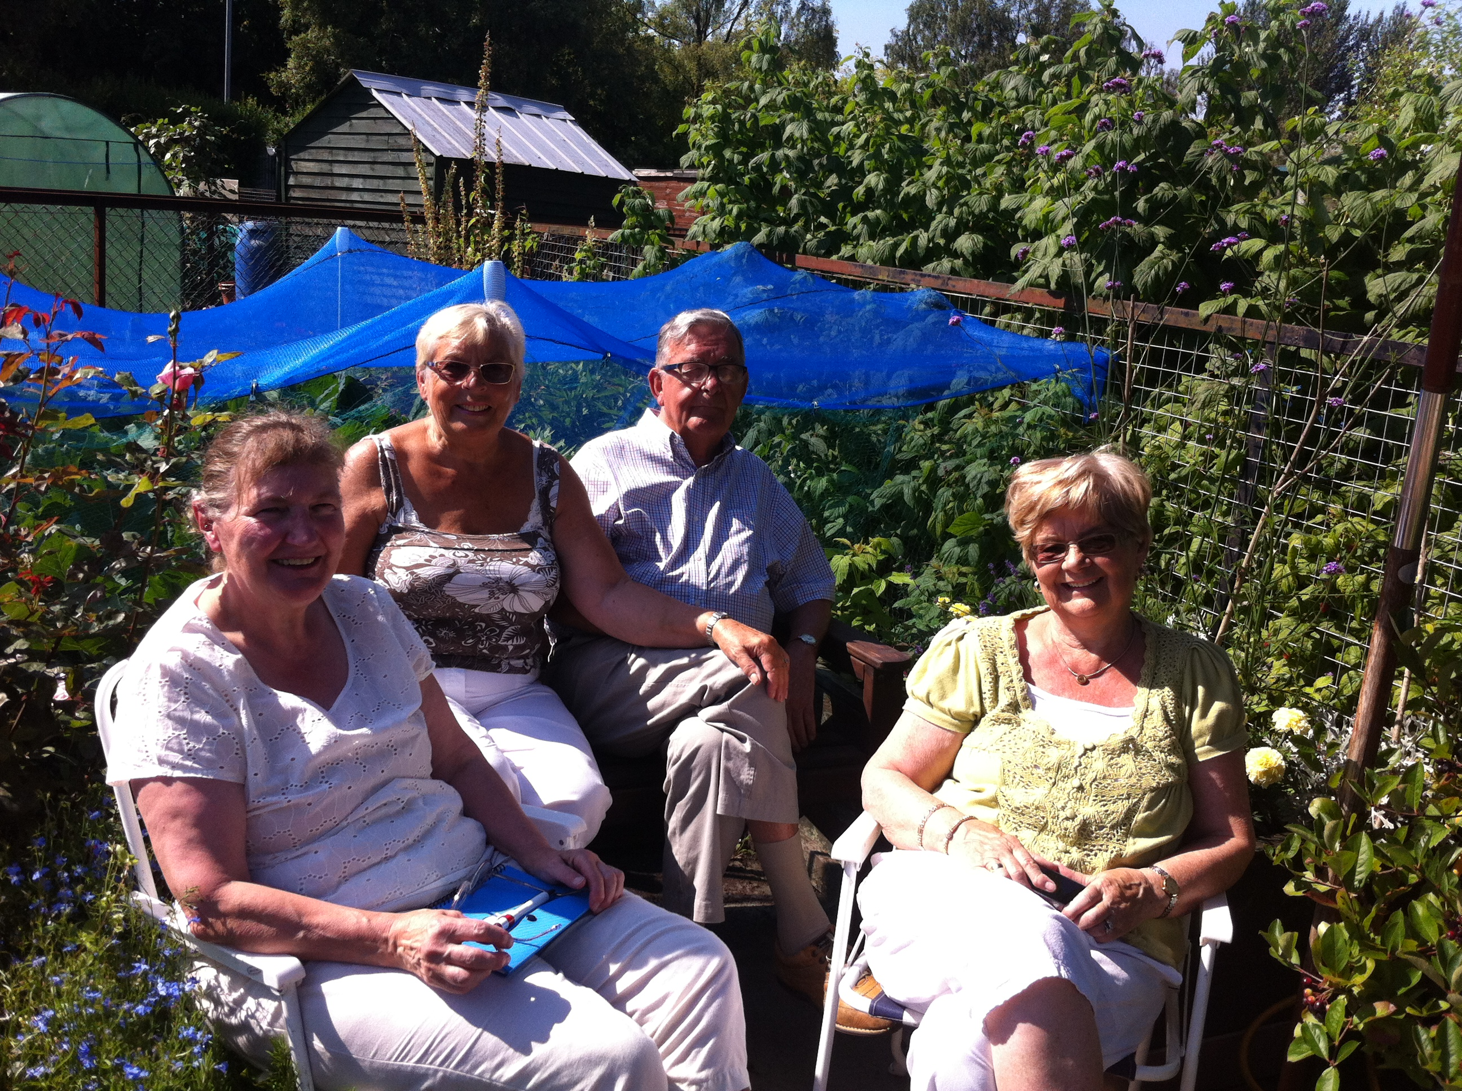

Alzheimer Scotland - Action on Dementia is a company limited by guarantee, registered in Scotland 149069. Registered Office: 22 Drumsheugh Gardens, Edinburgh EH3 7RN. It is recognised as a charity by the Office of the Scottish Charity Regulator, no. SC022315


Community Activities
West Dunbartonshire

