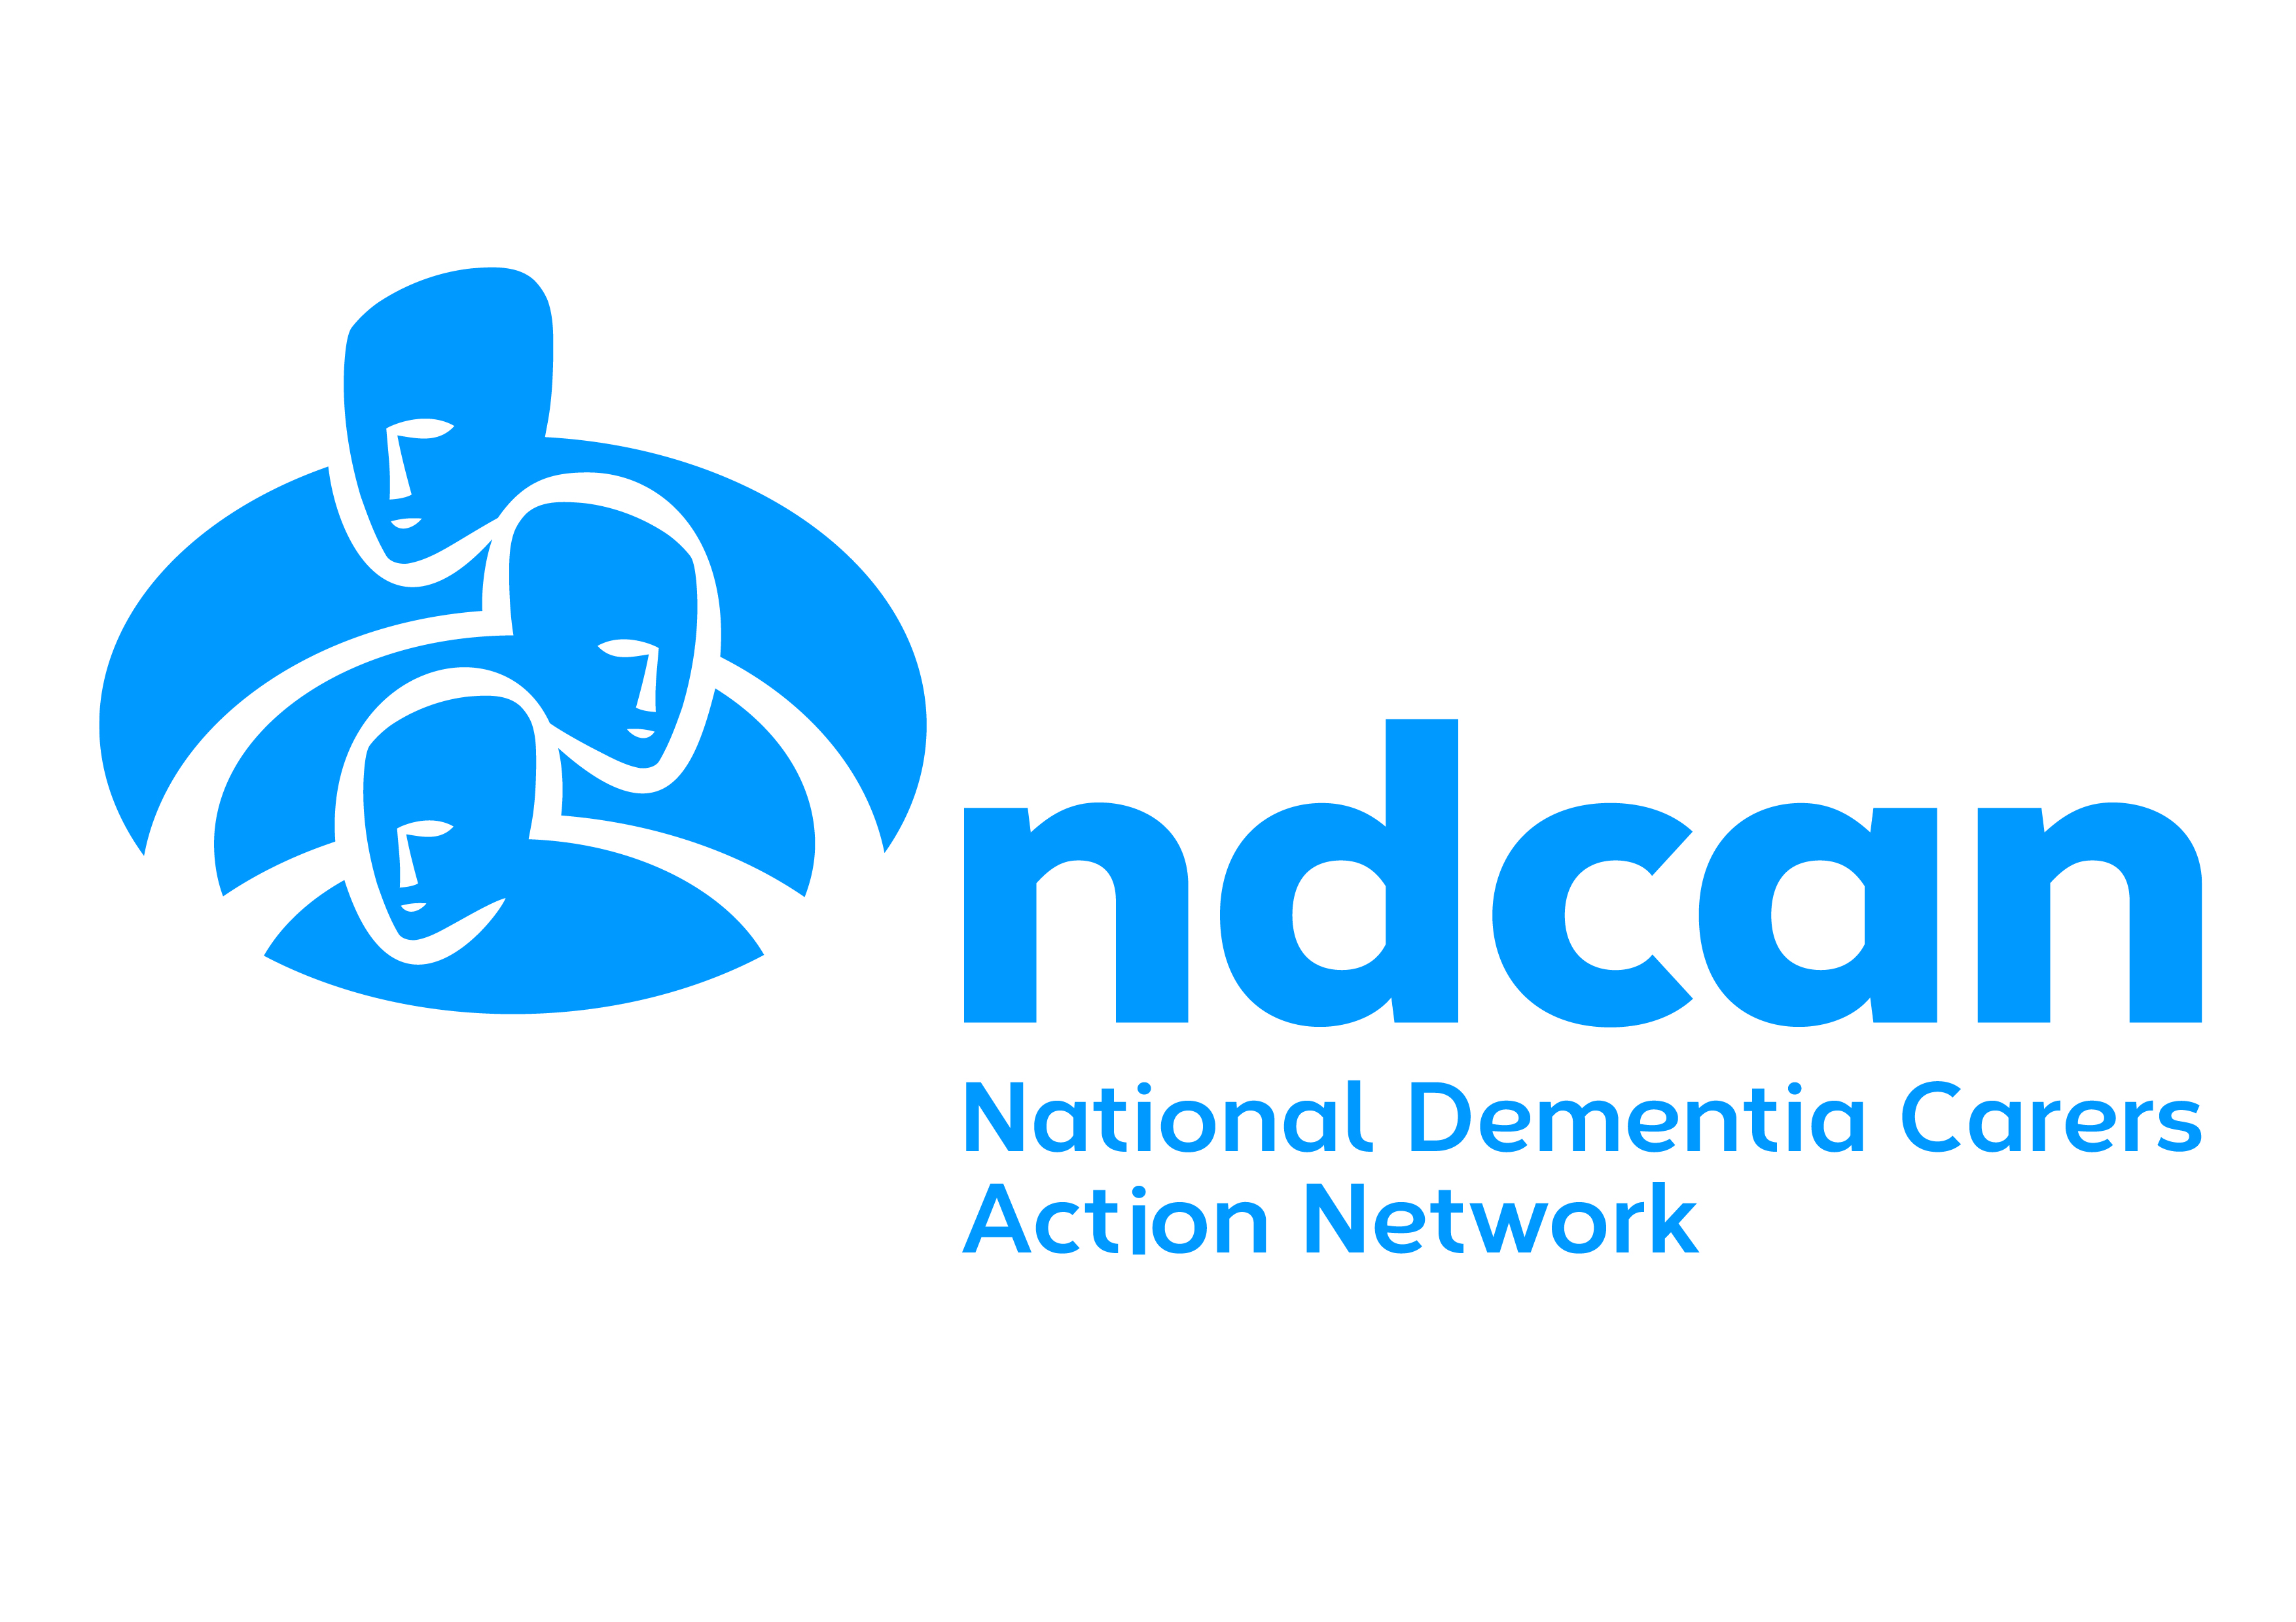
About Alzheimer Scotland’s
National Dementia Carers Action Network NDCAN
Alzheimer Scotland’s National Dementia Carers Action Network is a national campaigning and awareness raising group for carers of people with dementia. We exist to make the voices of carers heard and raise awareness of the issues impacting on us as carers.
NDCAN was formed in 2011 and since then has:
- Met regularly with the Cabinet Secretary for Mental Health, Health Improvement and Sport and other politicians and senior figures
- Been fully involved in all of Scotland’s National Dementia Strategies, including work on testing models of community support, improving acute care in hospitals and the monitoring of better support for people newly diagnosed with dementia (‘post diagnostic support’) as well as advance illness / end of life
- Helped to develop a new framework of training for staff who work with people with dementia and carers and support the training
- Spoken at a wide range of conferences in Scotland, the UK and abroad
- Taken part in many awareness raising activities
- Helped to develop new resources for carers on a range of subjects, including early onset dementia, continence and speech therapy
- And much, much more…!
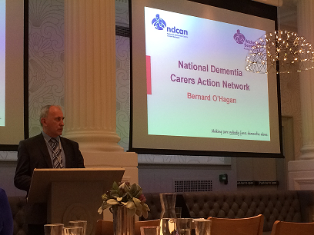
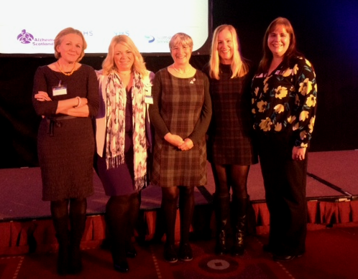
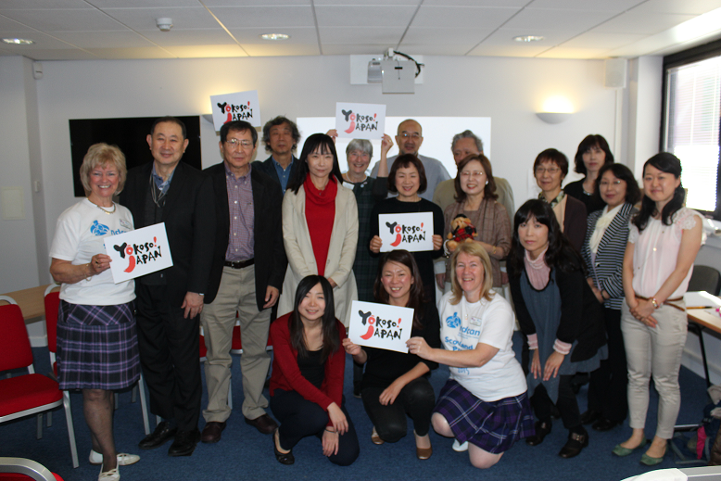
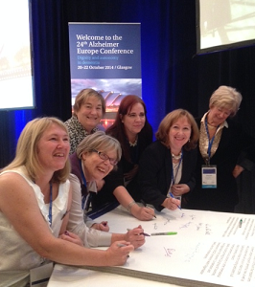
Who can join?
NDCAN is open to anyone who has experience of caring for someone living with dementia. Members all live in Scotland or care for someone who lives in Scotland. NDCAN is a national campaigning group, aiming to make the voices of carers heard and raising awareness of the issues impacting on us as carers at a national level.
What happens when I join?
All members are invited to two meetings a year. The meetings are good opportunities to contribute to the direction of the group, learn about new areas of work in dementia policy and strategy and meet other carers. There will be lots of opportunities for you to get more involved if you want to.
Why join NDCAN?
By joining NDCAN you are adding your voice to carers of people with dementia across Scotland to make sure dementia carer issues are heard. You will be part of influencing the future of dementia policy and strategy in Scotland and make things better for the people who come after us.
You will also get the opportunity to meet a wide range of people and have a lot of fun! On a personal level, many members of the group speak about the benefit they’ve felt through contributing in this way.
The committee
NDCAN has a committee of up to 14 people who are elected at our Annual Members Meeting. The committee meet every 6 weeks or so and will drive forward the work set by the wider membership: the “Friends of NDCAN”.

I want to get involved in local issues

NDCAN focuses on campaigning and awareness raising at a national level. However, there will also be opportunities for you to get involved in campaigning at a local level, for example through working with your local health and social care partnership to ensure carer’s voices are heard. If you are interested in getting involved in local issues please tick the box on page 5 of the membership form.
Staff support
NDCAN are supported by three members of Alzheimer Scotland staff – Jane and David, who are both National Coordinators and Caroline, the Administrator, who works with the group five hours a week. The staff team are there to support the group in the work they do.
Other ways to stay in touch
Meetings give all members a chance to get involved. However, we recognise that not everyone is able to get to meetings but would still like to contribute and show their support for the group.

An e-newsletter is produced and sent to all members. This gives all kinds of information, keeps members in touch with what NDCAN are doing and has easy ways for you to get involved.
We are working to create new ways to involve members who cannot get to meetings. If you have any suggestions of how to do this or would like to get involved in helping us with this please let us know.
How much does membership cost?
Membership is free! We can also help with transport and accommodation costs to enable you to attend meetings and get involved although we do ask that members join our parent organisation Alzheimer Scotland: - also free for carers.

How do I join?
Complete the attached application form and return it to the address below.
Once we’ve received your form we will arrange a time to meet to talk more about how you can get involved.
Getting support to be involved
Please tell us about anything you need to help you participate in meetings and activities. We will always try to help.
Getting support in your caring role
We recognise that many carers face challenging situations in their day-to-day lives. NDCAN strongly believes that every carer should receive the support they need in their caring role at the time they need it.
As a collective campaigning group, NDCAN are not able to offer individual support or advocacy to help you with your individual situation. However, the staff team will always do their best to ensure that members are connected with the appropriate support in their local area. If you have any concerns about this please talk to us.
How is NDCAN funded?
The Scottish Government currently provides funding to Alzheimer Scotland to support NDCAN.
Contact details
National Dementia Carers Action Network (NDCAN)

Address:  Alzheimer Scotland  81 Oxford Street  Glasgow G5 9EP  Tel:  0141 410 0100 or 0131 243 1467 | E-mail: ndcan@alzscot.org  Website: http://tinyurl.com/mv9ry3d  National Coordinators:  Jane Hasler and David Beyt  Administrator:  Caroline Russell



