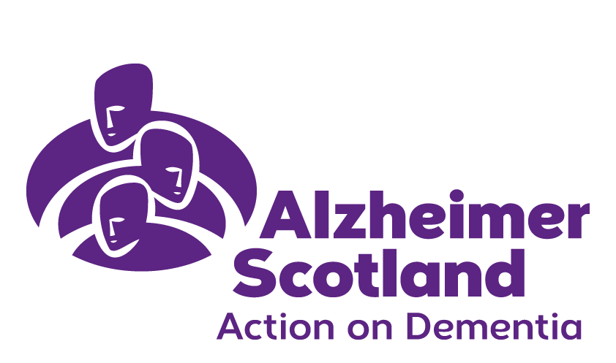
May 2018
Forth Valley Services
Newsletter

Welcome to our spring/ summer
Newsletter

Alzheimer Scotland Dementia Awareness week Conference
8th June 2018
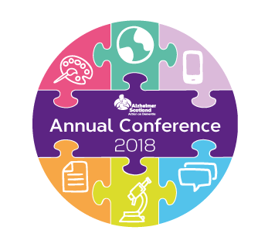

Location:
EICC, The Exchange, Edinburgh, EH3 8EE

Making sure nobody faces dementia alone

Do you share our passion for improving the lives of people living with dementia and their families? Perhaps you’re already doing it?

Join us at the Alzheimer Scotland annual conference to meet bold practitioners and inspirational leaders, and hear the latest big ideas in policy, practice and research. Book your ticket today to take advantage of our early bird rates.

This year’s conference will explore how we can work together to make sure nobody faces dementia alone. Through plenaries, presentations and pitches, we’ll investigate how to close the gap between policy and practice, design a digital strategy that is inclusive of people with dementia, delve into the future of dementia research and much more.

Find out more, including further details about the programme and sponsorship/exhibitor opportunities on the Annual Conference website. For any enquiries please call 0141 410 0104 or email conference@alzscot.org.

Complimentary tickets are available for people living with dementia and family members or carers.

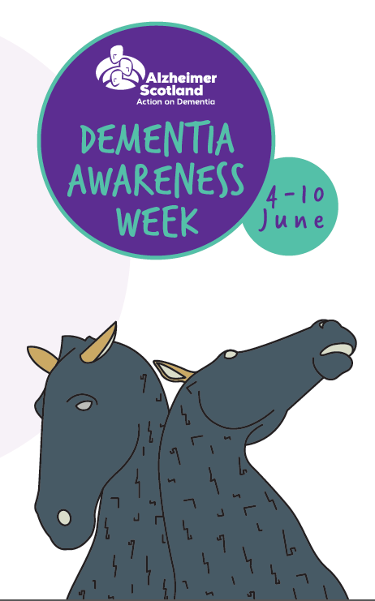

Maples
Open Day

Date: Saturday 9th June 2018
Time: 10am to 2pm

Venue: The Maples, 33 Johnston Avenue,
Stenhousemuir, FK5 4JZ

Earlier this year we completely refurbished our day care centre in Stenhousemuir and are delighted to have such a bright, warm, welcoming space. It’s incredible what good design and a lick of paint can do. Our ladies and gents who attend are really pleased with the refurbishment. We’re holding an open day to showcase the premises and we hope you can join us on the day.
The Garden Club has been hard at work growing bedding plants to sell and we will have home baking, teas and coffees on the day too.

We hope you can make it.

Carers (Scotland) Act 2016


The Carers (Scotland) Act 2016 was passed in the Scottish Parliament on February 4, 2016 and came in to effect on April 1, 2018.
It will ensure better and more consistent support for carers so that they can continue to care, if they so wish, in better health and to have a life alongside caring.

The Act places a number of duties on Local Authorities and Health Boards including offering support to adults and young carers through the completion of Adult Carer Support Plans and Young Carer Statements.

It also includes a duty to involve carers in Hospital Discharge Planning and the publication of Local Carers Strategies, with carers, setting out how they will provide services and support to carers in the future.

Local Authorities are also required to publish Local Eligibility Criteria outlining the levels of support carers can expect and these will be published in the near future.

Find out more from the Scottish Government on the latest programmes and initiatives regarding unpaid carers on their website. www.gov.scot/Topics/Health/Support-Social-Care/Unpaid-Carers

Forth Valley Memory Walk
16th September 2018

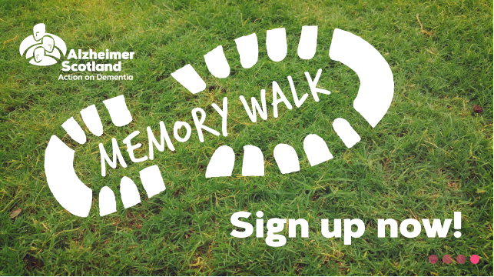

Make your mark in 2018 by taking part in the Forth Valley Memory Walk. Whether you’re walking for mum, dad, partner, grandma or granddad or friend join thousands of others making sure nobody faces dementia alone.

Venue: SUIP Scion House Stirling University Innovation Park Stirling FK9 4NF
Time: 12.00pm
Walk start time: 1pm

To register please visit our website www.alzscot.org

New Groups.

Cooking with Confidence

We recognize that many people can feel less confident preparing and cooking a meal so we have set up a small weekly group that supports people to plan, prepare and cook a meal together. After all the hard work is done it’s nice to sit down and enjoy the meal and chat with friends.

Where: Maples.
When: Weekly on a Thursday
Time: 3.30pm-5.30pm
Cost: £5 per session

If you would like to join this group please contact:
Anne Christian Community Activities Organiser on 01324 559480 or email her at achristian@alzscot.org

Food With Friends



Following on from the success of the weekly café people felt an evening meal would also be something they would enjoy and we now offer this each month at the Hotel Cladhan in Falkirk.
It’s a great opportunity to meet up with friends, chat to the link workers and feel supported.

Where: The Hotel Cladhan, Kemper Rd, Falkirk.
When: 2nd Monday of each month

Time: 17.45pm
Cost: 2 courses £10 or 3 courses for £12

If you would like to come along please register your interest with:
Anne Christian Community Activities Organiser on 01324 559480 or email her at achristian@alzscot.org

What’s on….

Brain Gym

Where: Camelon Education Centre.
When: Weekly on a Wednesday
Time: 1pm – 3pm
Cost: £5 per session.
Refreshments provided.
This group is aimed at people in the earlier stages of dementia to promote well-being and self-management. It is a ten week programme that adopts the principles of Cognitive Stimulation Therapy which is an evidenced based treatment, supported by NICE guidelines that focus on strengthening and maintaining: Orientation, short and long term memory, focus, attention and concentration along with communication and problem solving.
If you would like to attend please contact Anne Christian Community Activities Organiser on 01324 559480

Football Reminiscence:


Maples, Stenhousemuir
Last Monday each Month- 3.15pm-4.30pm

Corbie Inn, Bo’ness
Last Wednesday of each month 2pm-3.30pm

We now have vacancies for this group and would love to hear from you if you would like to attend.

Garden Club:
Maples, Stenhousemuir

Monday and Thursday
10.00am -12.00pm

Musical Memories – Singing Group
St Francis Xavier Church Hall
1st Monday of the month
11.30am – 12 noon (cuppa on arrival)

10 Pin Bowling/Walking Group:
Redbrae Road, Camelon or Callendar Park weather dependent.
Every Wednesday 11.30-12.30pm
New members very welcome


Drop In Cafes:
Every Thursday 10.00a.m. - 12 noon
Central Perks Coffee House, Grahams Road, Falkirk


Dementia Bowling Group
Camelon Indoor Bowling, Redbrae Rd, Camelon.

Weekly
Wednesday morning 10-11am
If anyone would like to attend please contact: Moira Thompson tel: 01324 875407
Cost is £1.25 per person.

If you would like more information regarding any of the above groups, or any of our services, please call the office on 01324 559480.



You can now keep up to date with everything that’s happening at the Falkirk Service by following us on Facebook. Just go to the link below and like the page.

https://www.facebook.com/Alzheimer-Scotland-Falkirk


