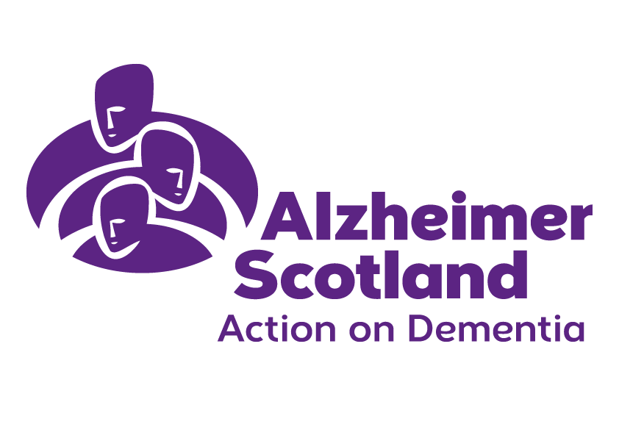April/June 2019

**Edinburgh Services**

Edinburgh Newsletter

Welcome to our April Newsletter

There are several events and initiatives I would like to share this edition:

Nominations are now open for **Scotland's Dementia Awards**. The awards recognise what can be achieved when people work together to improve the lives of people living with dementia. Entries are now open for 2019 and we want to hear from you! There's lots of exceptional and innovative work happening right across the organisation and these awards are the perfect opportunity to recognise dedication and effort. All entries are welcome.

Nominations are now open for the following award categories:

* Best Community Support Initiative
* Best Dementia Friendly Community Initiative
* Best Educational Initiative
* Most Innovative Partnership
* Best Hospital Care Initiative
* Best Care Home Practice Improvement

How to enter: Further information on the award categories, entry criteria and how to enter can be found on the Scottish Dementia Action website. Entries close at 5pm on Sunday 9 June 2019.

The **Alzheimer Scotland 2019 Employee voice** survey will soon be launched. This is a great opportunity to have your voice heard and to really influence the way forward in helping us to work together as one team delivering our shared vision and achieving our mission to make sure nobody faces dementia alone. Ahead of the launch of the survey itself, there will be a Q & A to help explain some more about the survey and how to take part.

**Launch of the Herbert Protocol in Edinburgh**

****The Herbert Protocol is an information gathering tool to assist the police to find a person living with dementia who has been reported missing as quickly as possible.  The Herbert Protocol has now been launched in Edinburgh. The Herbert Protocol is a nationally recognised scheme supported and endorsed by Police Scotland.  The initiative was first developed by Norfolk Police. It is named after George Herbert, a war veteran of the Normandy landings, who lived with dementia. If you would like a form please give us a call and we’ll get one to you.

**Franks Law**

Widow and Frank's Law campaigner Amanda Kopel successfully campaigned for new legislation which would mean anyone who is assessed by their local authority as requiring personal care will receive it free of charge.

Franks Law came into force on 1st April 2019. The legislation ends age discrimination in relation to personal care. For the first time everyone under the age of 65 who is assessed as requiring personal care will receive it for free.

If you would like any more details about any of the above, please call the Edinburgh office on 0131 551 9350.



Lisa Moodie

Locality Resources Co-ordinator

Information Section

We are always looking for information on interesting events that we can pass on in our groups and Newsletters. If you have anything you feel would be useful to other people let us know and we will include it in our next newsletter.

GALLERY SOCIAL EVENTS

The new Gallery Social booklet is out for April to September 2019. If you haven’t already received one let us know and we will send one out to you. There are all sorts of events at the galleries, libraries, museum and the zoo which I know a lot of you are already finding interesting and enjoyable.

EDINBURGH FESTIVAL THEATRE

The Festival Theatre are able to continue to enhance their Dementia Friendly work due to continuing funding from Life Changes Trust. Details on what they provide can be found on their website:

[www.capitaltheatres.com/take-part/dementia-friendly-work](http://www.capitaltheatres.com/take-part/dementia-friendly-work)

VOCAL

Vocal have published their up to date Carer learning and leisure events brochure for April – June 2019. There are a lot of events going on at VOCAL so I would urge you to check this out. Contact details are below or you can pop into the foyer and pick up a leaflet from their Carers Hub at 60 Leith Walk, Edinburgh EH6 5HB.

USEFUL CONTACTS

I would like to remind you of the useful services provided for carers by two organisations in Edinburgh:

Care for Carers [www.care4carers.org.uk](http://www.care4carers.org.uk) 0131 661 2077

VOCAL [www.vocal.org.uk](http://www.vocal.org.uk) 0131 622 6666

Paula Frame

Practice Team Leader



We would welcome any comments/suggestions which you think would help us to improve the service we provide. Email us at edinburghservices@alzscot.org or call 0131 551 9350.

**Day Opportunities Group**

It’s been a busy start to the year for Day Opportunities. In addition to our familiar in-house activities, walks and café visits, there have been a number of highlights.

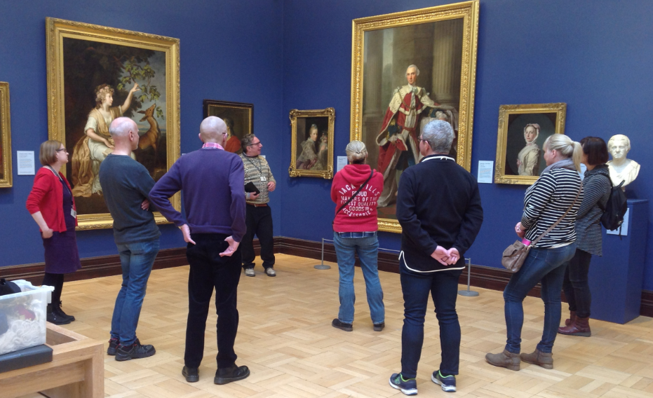The Monday and Wednesday groups have thoroughly enjoyed participating in workshops at the National Portrait Gallery, with respective themes of reminiscence and photography. These were delivered with great passion and enthusiasm that was appreciated by all.

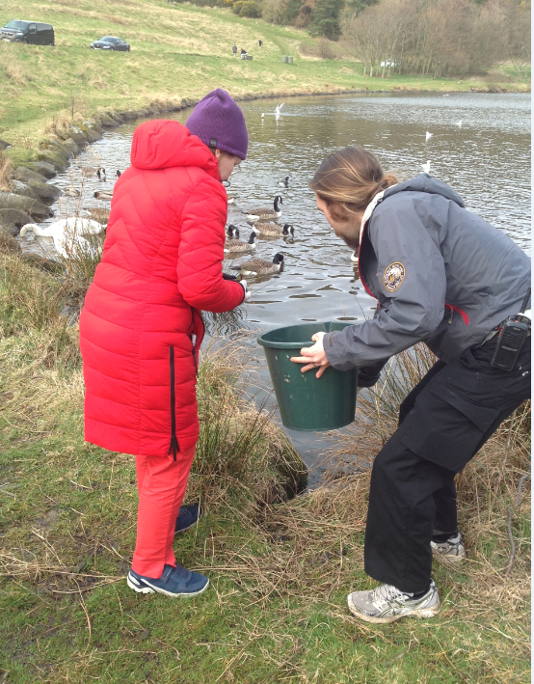

The Wednesday and Thursday groups spent a morning at Holyrood Education Centre. Interesting and informative talks were followed by a ranger-led tour of the park and opportunity for some hands-on activity, including toad rescuing (!), with the Thursday group making the most of an unexpected visit to the beautiful and peaceful Dr Neil’s Garden by Duddingston Loch.

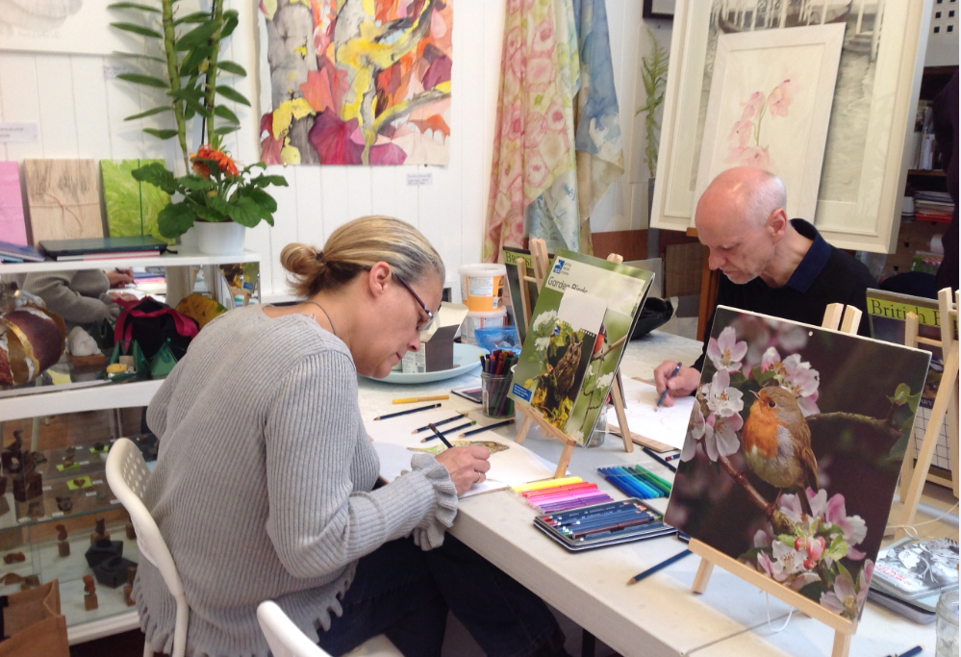

Three of our groups have now benefitted from the excellent art workshops at Four Abercorn Gallery, with our fourth group scheduled for their session in May. These have been a huge success, generating many positive comments and high levels of focus and engagement. Please see the back page of this newsletter for our gallery.

We also took advantage of the opportunity to see the Edinburgh Street Photography Exhibition at the City Art Centre, and the Andy Warhol Exhibition at the Dean Gallery. Both of these evoked strong memories and prompted interesting discussion.

The Tuesday group recently braved some unexpectedly blustery weather on a guided walk at the top of Calton Hill. The views of the city and beyond were stunning and we are looking forward to returning in the summer months to do a bit more exploring.

And last but not least…

*“There’s always room for a story that can transport people to another place”* J.K.Rowling

Absolutely! Lynsey from Burgh Blatherers storytelling group spent several mornings getting to know our Tuesday group prior to engaging them in a moral fable appreciated by all. We hope to continue these highly inclusive sessions as a regular part of our timetable going forward.



Lesley Jaap  
Day Opportunities Organiser

**National Dementia Awareness Week**

Monday 3rd June 2019 to Sunday 11th June 2019.

Please see below for the details of events. For more information give us a call on 0131 551 9350.

|  |  |  |
| --- | --- | --- |
| **Alzheimer Scotland Annual Conference 2019** | | |
| **Monday 3rd June 2019** | 10am to 4pm | EICC, The Exchange, 150 Morrison Street, Edinburgh, EH3 8EE |
| The theme of this year’s conference is Prevent now – Care today – Cure tomorrow. Please see attached flyer. | | |
| **Edinburgh Leisure, Movement for Memories** | | |
| **Tuesday 4th June 2019** | 11am to 1pm | Alzheimer Scotland, 160 Dundee Street, Edinburgh, EH11 1DQ |
| A taster session with the Movement for Memories project involving seated exercise for people living with dementia and carers, then get more information from the Movement for Memories staff about what else they offer. We will finish off with a sandwich lunch. This session will be supported by Movement for Memories and Alzheimer Scotland Staff. This is a free event.  **20 places available – to book a place call the Edinburgh Service on 0131 551 9350** | | |
| **Festival Theatre Tea Party** | | |
| **Wednesday 5th June 2019** | 2pm to 3.30pm | Festival Theatre, 13-29 Nicolson Street, Edinburgh, EH8 9FT |
| An extra special tea party with a first performance by the Capital Theatre’s House Band made up from professional musicians who all happen to be Theatre staff too! Listen to Scottish favourites and join in with songs from our school playground days. The Alzheimer Scotland Edinburgh Team will also be there with lots of information and advice.  **Cost is £2 per person and carer comes along free, the money from the ticket sales will be donated to Alzheimer Scotland. For a ticket please call the Theatre Box Office on 0131 529 6000.** | | |
| **Dementia Drop-In Session** | | |
| **Thursday 6th June 2019** | 2pm to 3.30pm | The Prentice Centre, 1 Granton Mains Avenue, Edinburgh, EH4 4GA |
| If you would like some information or advice about Dementia, or would like to know a bit more about our work in Edinburgh then please come along to our drop in session with the Dementia Advisor. | | |
| **Outing to the Kelpies** | | |
| **Friday 7th June 2019** | 10am to 3.30pm | Felix Park, Falkirk, FK2 7ZT |
| This is a free trip for people living with dementia and their carers/family members (including transport there and back from City Centre location) and will include a guided tour. The outing will be supported by Alzheimer Scotland staff.  **26 places available (maximum of 2 per person) -to book a place call the Edinburgh Service on 0131 551 9350.** | | |



Elizabeth Campbell  
Dementia Advisor

D Cafe

*The last Thursday of every month*

*Quaker Meeting House, 7 Victoria Terrace, Edinburgh, EH1 2JL*

*From 1pm to 3pm*

*This café is run by Alzheimer Scotland Volunteers*

The aim of our café is to provide a very informal meeting place for people with dementia and their cares. It provides a place to get information and to meet up with others in the same situation. The second half of the meeting is usually spent listening to a speaker on a variety of topics or being entertained by musicians.

*Please note the café does not take place in August or December.*

Occasionally the group go on outings so if you would like to come along please call ahead to ensure the Café will be running as usual.

For more information please call the Edinburgh Service on 0131 551 9350.

Purple Alert

Be part of a community that can assist people with dementia if they lose their way. Download the Purple Alert app to:

* raise an alert
* report sightings
* get updates

Dementia helpline and website

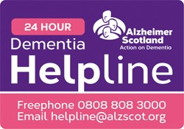

The 24 hour Dementia Helpline is a freephone Scottish service for people with dementia, carers, relatives, professionals, students and anyone concerned about dementia. You can call 0808 808 3000 anytime and email us: [helpline@alzscot.org](mailto:helpline@alzscot.org).

Further information about dementia and the support we provide can be found on our website [www.alzscot.org](http://www.alzscot.org).



**Follow us on Facebook at Alzheimer Scotland – Edinburgh and Lothians**

Day Opportunities Artwork

|  |  |
| --- | --- |
|  |  |
|  |  |
|  |  |