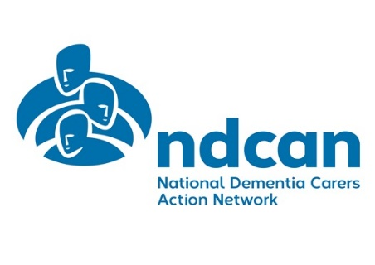

National Dementia Carers Action Network
NDCAN
Membership Form
Are you a family member or friend of someone living with
dementia? Do you provide them with care and support?
Would you like to be part of a group of people from across Scotland who want to make their voices heard?
Then you should join Alzheimer Scotland’s
National Dementia Carers Action Network

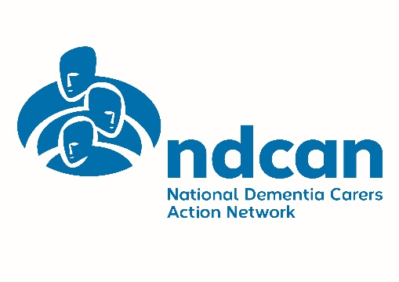

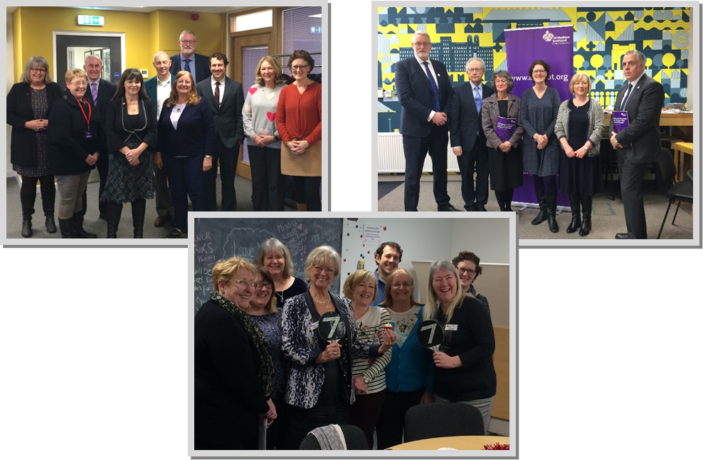

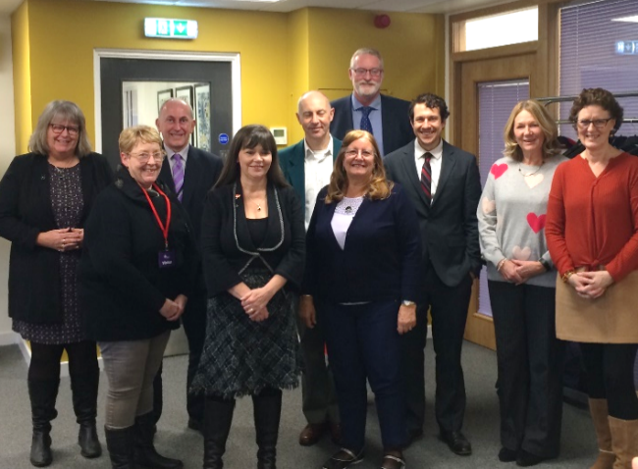
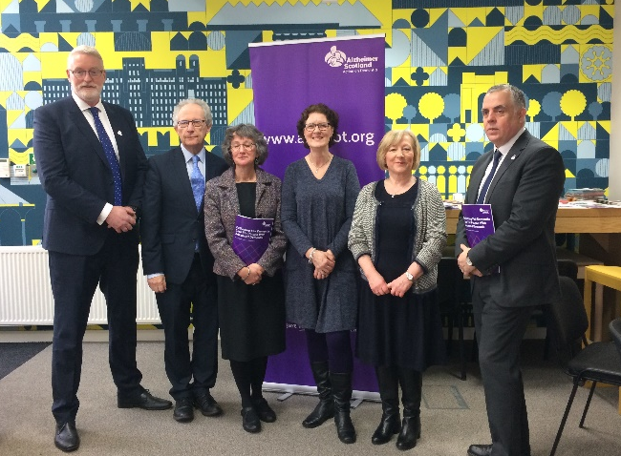

About NDCAN

The National Dementia Carers Action Network (NDCAN) is a national, member led, campaigning and awareness raising group for carers and ex carers of people living with a diagnosis of dementia in Scotland. NDCAN was established in 2011 and exists to make the voices of carers heard and to raise awareness of the issues impacting carers.
We are funded by Alzheimer Scotland and the Scottish Government and are the independent voice of dementia carers within Scotland.
The remit of NDCAN is:
- To campaign and raise awareness at both a national and local level.
- To engage with, and inform, Scotland’s National Dementia Strategies.
- To feed into other government consultations and policies.
- To promote and raise awareness among heath, social care and related professions, as well as the wider public.
- To work with all stakeholders at a national and local level, including national and local government, private and voluntary providers of health, social care and housing, and other relevant bodies.
- To work with other representative groups such as the Scottish Dementia Working Group (SDWG).

NDCAN is open to anyone in Scotland who has experience of unpaid caring for someone living with dementia. For more details please see www.alzscot.org/ndcan
How to join

We are very happy to have new members! To join please complete this application form and return it to the email address at the bottom of the form.
Once you’ve returned the form, we will arrange for you to meet with a member of NDCAN staff and a group member. This is an opportunity for you to get to know more about the group and for us to get to know you. Please note that all our meetings are currently held online using Microsoft Teams.
What happens if I join?

When you join NDCAN you will join a network of carers of people with dementia from across Scotland. You will receive email updates on the group’s work and easy ways to get involved. You will also have the opportunity to get involved in consultations, attend events on behalf of the group, share your experiences and opinions on different areas the group are working on and even put yourself forward to join the NDCAN committee.

About this form

If possible, please complete all the sections on this page and the final page for our records. All the information on the other pages is optional. It is very useful to us – but only fill it in if you want to.
Your personal details
Name:
Address:
Email:
Tel: Mobile:
Please tell us a bit about your caring role:
The following information is voluntary, but it will help us build a better picture of our
membership if you are willing to provide it. This information is treated confidentially and will not be shared with other members.
Who do you support with dementia? (husband / wife / mother / father / cousin etc.)

When were they diagnosed? (year)
Details of their condition (type of dementia etc.)

Do they live with you or elsewhere?

Is there any more information you would like to share?

Are you a member of any other Carer Groups or Networks? Please give details.

Local issues
NDCAN mainly focuses on campaigning and awareness raising at a national level. There
may also be opportunities for you to get involved in campaigning at a local level, for example through working with your local health board or social work department to ensure carers’ voices are heard. If you are interested in getting involved in local issues, please indicate below.
Yes / No
Could you help us with our campaigns?

NDCAN are always working to improve the lives of carers of people with dementia.
To help us with this, we are collecting stories of both good and bad practice. Would you like to share your experience? We will contact you to discuss the best way to collect your story.
Yes / No
Are you willing to be interviewed about caring for someone with dementia
by the media?
Someone from Alzheimer Scotland or NDCAN will always ask you first before putting any journalist or supporter in touch with you and someone will be present with you when you
are interviewed if you wish
Yes / No
Please complete this section and return this form to NDCAN@alzscot.org
DATA PROTECTION
The Data Protection Act says that we need your permission to keep this information on file.
I agree for Alzheimer Scotland to keep this information on its records.
(We will not use it for any purpose other than matters relating to NDCAN, and will ask your permission first if we wish to share it with anyone else)
SIGNED: DATE:
Contact Details
Email - NDCAN@alzscot.org
Website - www.alzscot.org/ndcan
Follow us on Twitter - @NDCAN_Scotland

