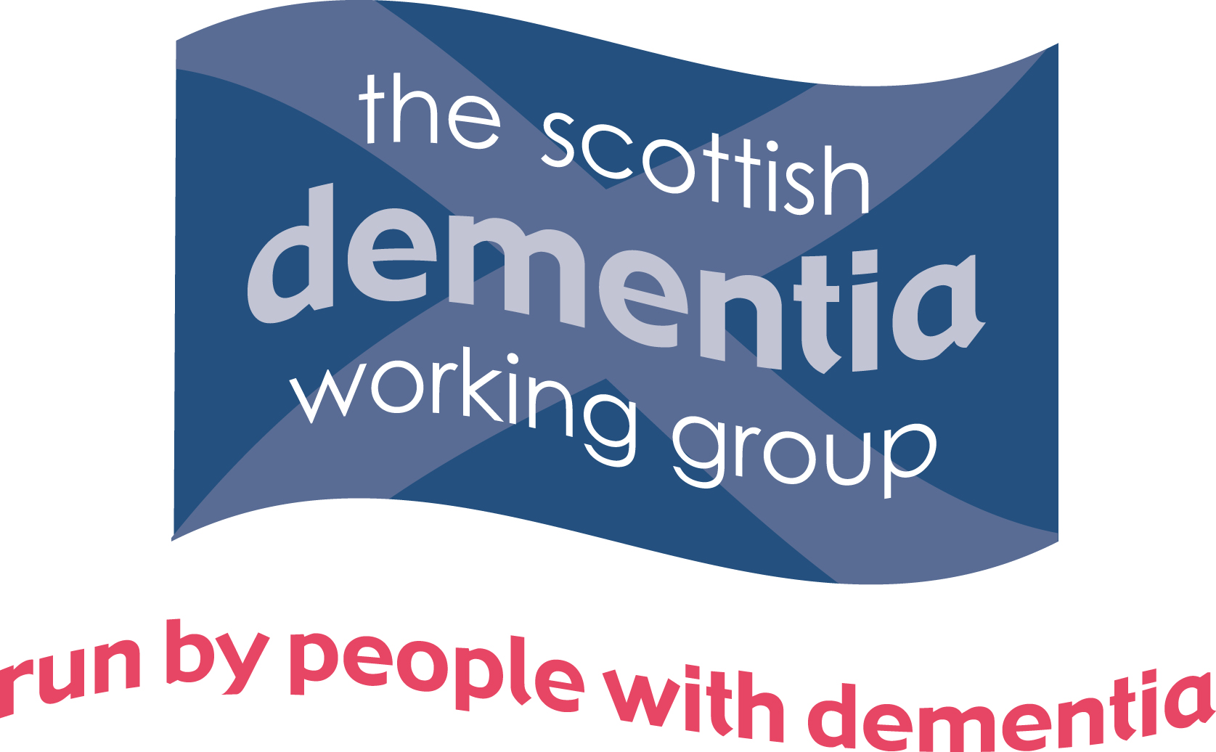

Scottish Dementia Working Group
Research Expression of Interest Form
The Scottish Dementia Working Group (SDWG) is a national campaigning and awareness raising group, whose members all have a diagnosis of dementia. SDWG provides a platform and a greater voice to empower those with a diagnosis of dementia to influence and inform dementia policy and practice, at a local and national level, throughout every stage of the dementia journey and in every setting.
Section A: Please provide the following information
Project title
Name & correspondence address of the Principal Investigator (PI):
E-mail address for correspondence:
Has ethical approval to conduct the research been obtained? (YES/NO*)
(If YES) Name & Contact Person
of the Ethics Committee:
Copy of PhD if relevant

Section B: In no more than 350 words, please describe (in the box below): The aims of the research; what is being asked of people with dementia; how the research will benefit the Scottish Dementia Working Group (or people with dementia more generally) and when you need a decision:
- Aims of the research
- What is being asked of people with dementia
- Benefits to the SDWG
- Benefits to the individuals taking part in the research
- The date by which the researcher/s need a decision

Continued on next page

Information for Researchers Seeking to Collaborate with the Scottish Dementia Working Group Completing the Research Expressions of Interest Form
Please Note: ALL applications for SDWG support must go through our formal review process. Approaching individual members of the group may result in requests being automatically rejected.
When completing the form, please ensure that:
- You use a minimum font of Arial 14 throughout
- You use double-spacing
- You use plain English; avoiding jargon, long sentences and acronyms wherever possible
- You avoid long sentences – keep it simple
- You explain any specialised terms (e.g. triangulation)
You will be contacted once the SDWG has had an opportunity to review your request. Please note that you may be asked to provide additional information about the research project.
Once completed please send to: activevoice@alzscot.org

* Please note that the SDWG will only consider collaborating in research projects that have already received ethical approval.

